**🐍 Python Tasks (Functions + Loops)**

1. Write a function to print even numbers from 1 to 50.
2. function even(num) {
3. for (i = 1; i <= num; i++) {
4. if (i % 2 == 0) {
5. console.log(i);
6. }
7. }
8. }
9. even(50)
10. Write a function that returns the sum of the first N natural numbers.
11. function sum(num){
12. let sum=0
13. for(i=1;i<=num;i++){
14. sum+=i
15. }
16. return `sum of first ${num} natural numbers is ${sum}`
17. }
18. console.log(sum(10));
19. Write a function to check if a number is prime.
20. function prime(num) {
21. count = 0
22. for (i = 2; i < num; i++) {
23. if (num % i == 0) {
24. count++
25. break;
26. }
27. }
28. if (count == 0) {
29. console.log(`${num} is prime`);
30. }
31. else {
32. console.log(`${num} is not prime`);
33. }
34. }
35. prime(7)
36. Write a function that prints all multiples of a given number within a given range.
37. function mult(num,start,end){
38. for(i=start;i<=end;i++){
39. if(i%num==0){
40. console.log(i);
41. }
42. }
43. }
44. mult(2,1,10)
45. Write a function to generate the Fibonacci series up to N terms.
46. function fab(num){
47. let first=0;
48. let second=1;
49. for(i=0;i<num;i++){
50. console.log(first);
51. next=first+second;
52. first=second
53. second=next
54. }
55. }
56. fab(10)

**🌐 JavaScript Tasks (Functions + DOM + Loops)**

1. Create a function that prints numbers from 1 to 20 in the console.

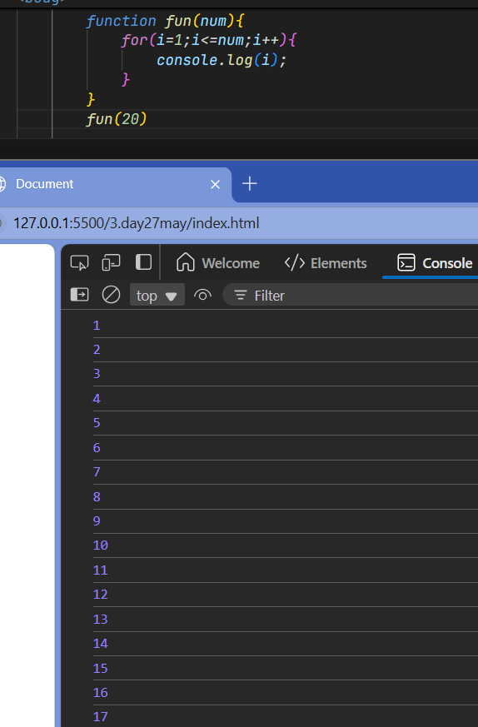

1. Create a button that calls a function to double a number entered in an input field.

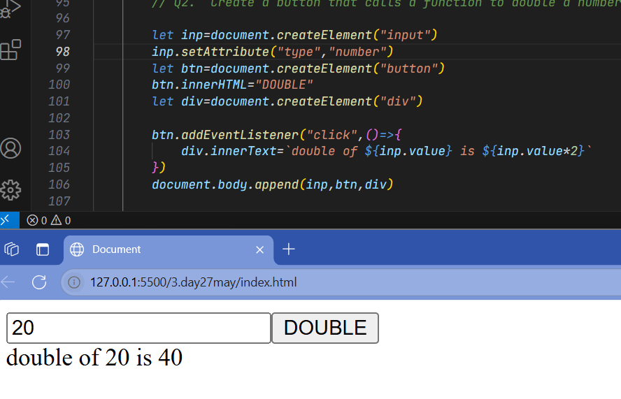

1. Write a function that returns the factorial of a number using a loop.
2. function fact(num){
3. fact=1
4. for(i=1;i<=num;i++){
5. fact*=i
6. }
7. return fact
8. }
9. console.log(fact(5));
10. Create a function to check if a given string is a palindrome (via alert or console).

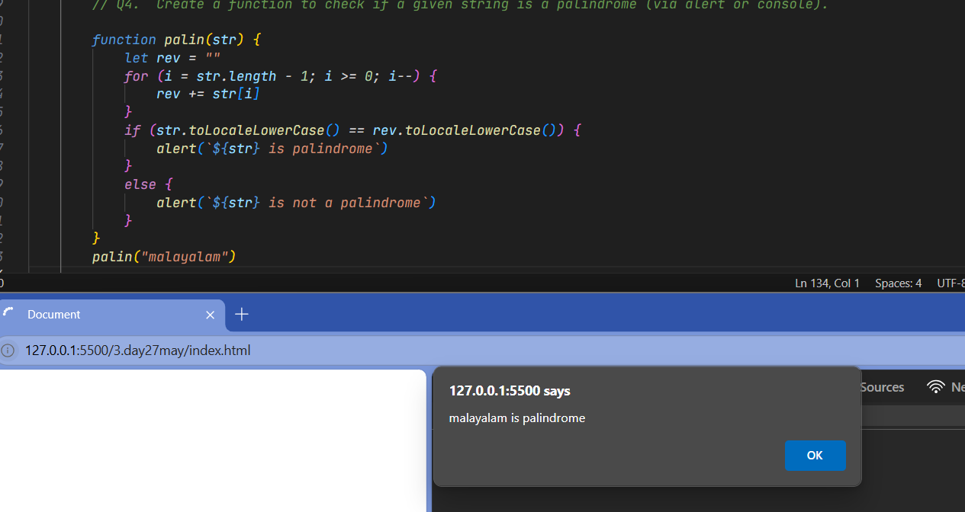

1. Add a button that calls a function to count vowels in a user input and displays it in a <div>.

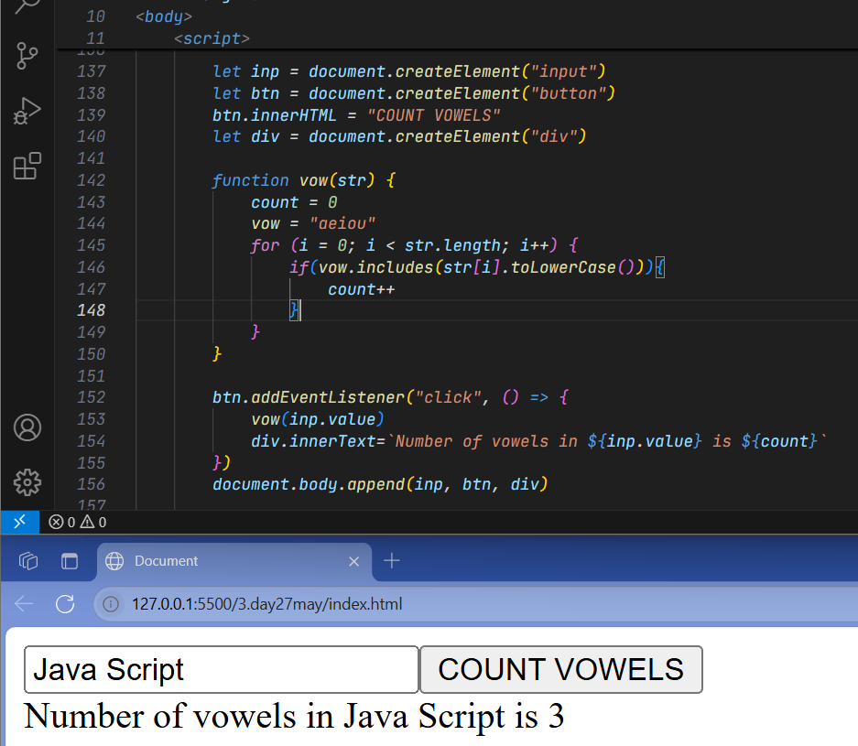

**🛢️ SQL Tasks (Practice with Functions & Queries)**

1. Create a table named employees with columns: id, name, salary.
2. Insert 3 records into the employees table.
3. Write a query to find employees with a salary greater than 50,000.
4. Write a query to increase the salary of all employees by 10%.
5. Write a query to delete all employees whose salary is below 30,000.

